1. If you want to view reports of all the traders, then you need to click on Report (View Traders Report) **CLICK HERE** button on the middle left of our Dashboard. After clicking on it will redirect you to Oracle Dashboard from where you can login with your username and password.

* Invalid Login Credentials.

* Valid Login Credentials.

1. After logging in with correct login credentials, you’ll have access to the various reports of trader. You can see Monthly Sales Performance, Sales Report, Product Review, and Pending Orders through various reports and graphs.

1. MONTHLY SALES REPORTS OF SHOP display reports of sales of various months and also specific report of product sold in past 30 days.

1. WEEKLY SALES REPORTS OF SHOPS display reports of sales of various week and also specific report of product sold in past 7 days.A screenshot of a computer

   Description automatically generated
2. PRODUCT_AND_REVIEWS display all the product and their reviews in master-detail page. The product is the master table and reviews are in the detail table.

1. Pending_Orders shows the orders that are not yet delivered or in collection slot. Orders part is master table that shows the pending order detail and products part is detail table that shows the product of that shop from the specific order.

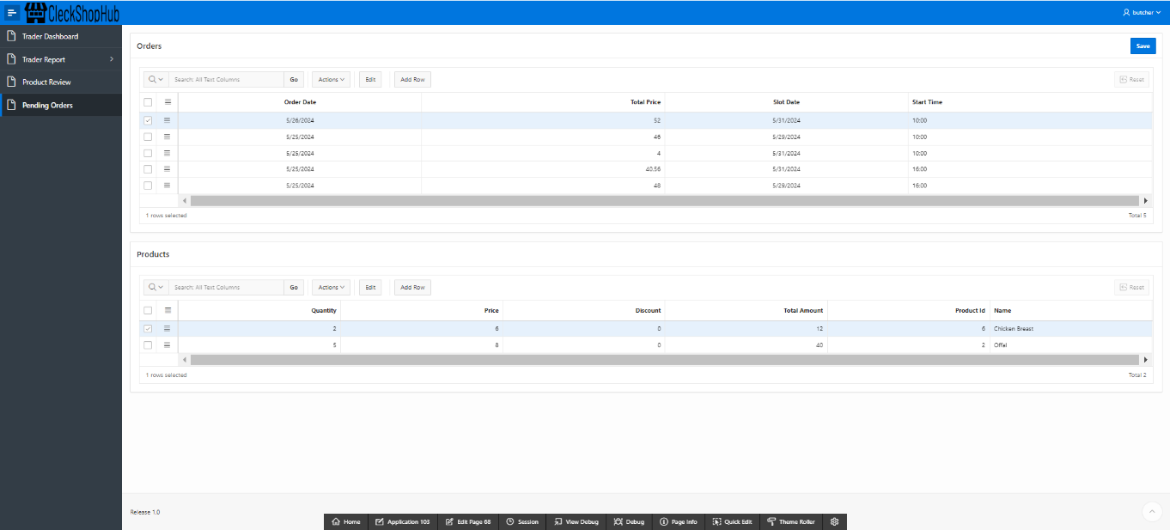

1. You can logout by clicking on username and then Sign out.

